Comparisons of Sweep net samples 2012 (LEC) vs 2017 (MHD)

* Each sweet net sample = 6 X 60 Sec sweeps
  + For 2012 data, 6 sweeps are reps. Combined in 2017

|  |  |  |  |  |
| --- | --- | --- | --- | --- |
| **Year** | **# sweep net samples** | **Total # gravid** | **Total #** | **Prop gravid** |
| 2012 | 14 | 601 | 3545 | **16.95346** |
| 2017 | 54 | 38 | 976 | **3.893443** |

Comparisons by year and Site

* + 2012: 3X per site
  + 2017: 4-5X per site

|  |  |  |  |  |
| --- | --- | --- | --- | --- |
| **Year** | **Site** | **Total gravid** | **Total number** | **Prop gravid** |
| 2012 | Black | 29 | 219 | 13.2420091 |
| 2012 | East | 18 | 134 | 13.4328358 |
| 2012 | Ice | 1 | 68 | 1.47058824 |
| 2012 | Piler | 84 | 1654 | 5.07859734 |
| **2012** | **Vulgaris valley** | **469** | **1470** | **31.9047619** |
| 2017 | Bunny hill | 2 | 80 | 2.5 |
| 2017 | Camp | 0 | 14 | 0 |
| 2017 | Golf | 20 | 134 | 14.9253731 |
| 2017 | Kforest | 1 | 42 | 2.38095238 |
| 2017 | Moz valley | 3 | 169 | 1.77514793 |
| 2017 | Oil | 10 | 128 | 7.8125 |
| 2017 | Seatom | 0 | 107 | 0 |
| **2017** | **Vulgaris valley** | **0** | **171** | **0** |
| 2017 | VV2 | 0 | 25 | 0 |
| 2017 | Waterfall | 2 | 99 | 2.02020202 |
| 2017 | Waterfall up | 0 | 7 | 0 |

Histograms for fecund individuals (egg # and wing length). Larger mosquitoes in 2012. Mean 63 vs. 34 eggs in 2017

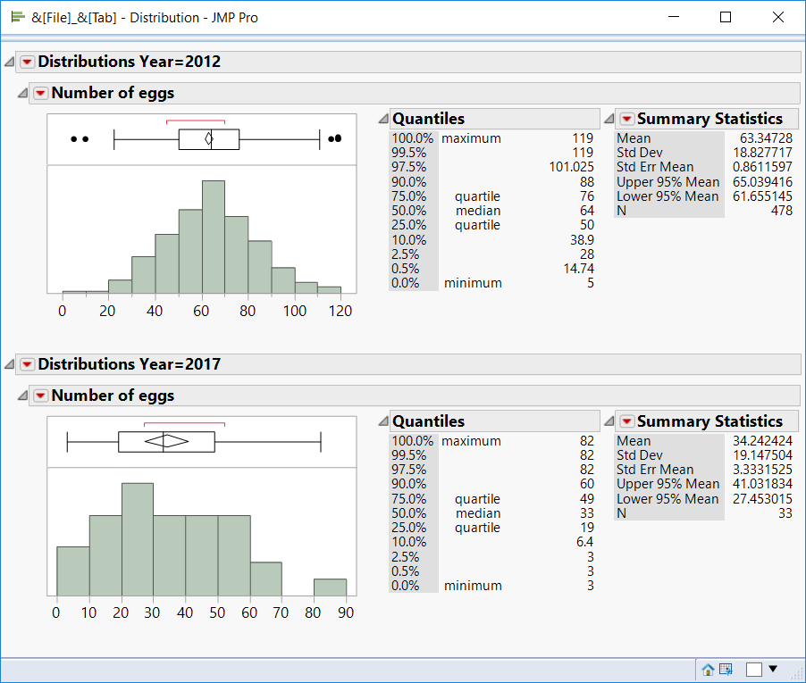

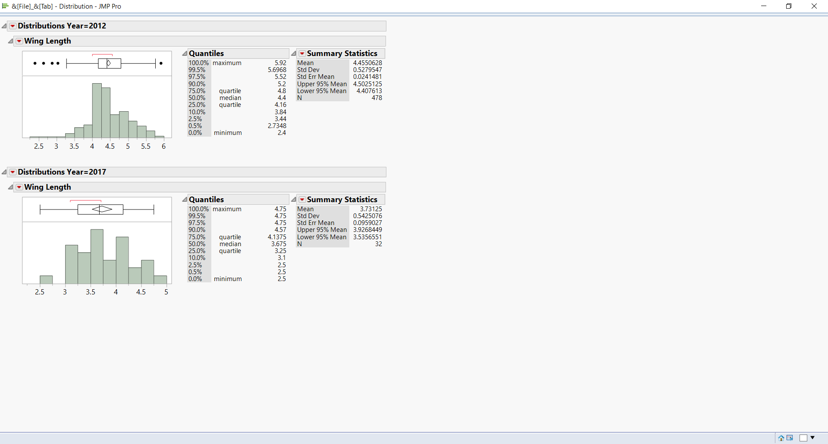

# of eggs vs. wing length for all fecund individuals 2012 and 2017

* Some individuals w/ very low # of eggs.

